CDMA

📶 What Is CDMA?
# Source: Chatgpt (GPT-5-Mini) at [1/23/2026]
CDMA stands for Code Division Multiple Access.
It is a 2G/3G mobile communication standard that allows multiple users to share the same frequency band at the same time by using unique digital codes to separate their signals.
🧠 Unlike GSM (which assigns time or frequency slots), CDMA lets everyone talk at once — but each signal is uniquely coded.

🛠️ Key Concept:
# Source: Chatgpt (GPT-5-Mini) at [1/23/2026]
📡 In CDMA, all users transmit on the same frequency simultaneously, and the system uses code-based separation to filter them.

🔍 Key Features:
# Source: Chatgpt (GPT-5-Mini) at [1/23/2026]
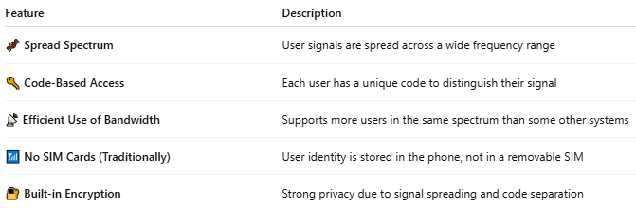

Feature | Description
🧬 Spread Spectrum | User signals are spread across a wide frequency range
🔑 Code-Based Access | Each user has a unique code to distinguish their signal
📡 Efficient Use of Bandwidth | Supports more users in the same spectrum than some other systems
📶 No SIM Cards (Traditionally) | User identity is stored in the phone, not in a removable SIM
🔐 Built-in Encryption | Strong privacy due to signal spreading and code separation

📲 CDMA vs GSM:
# Source: Chatgpt (GPT-5-Mini) at [1/23/2026]
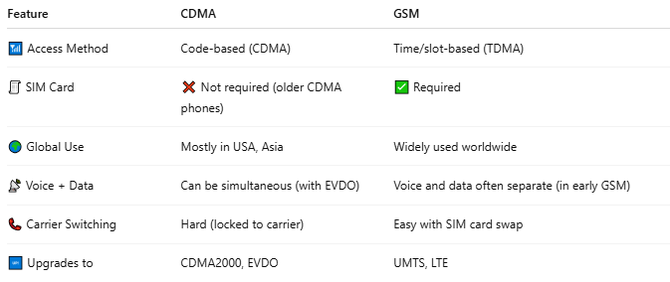

Feature | CDMA | GSM
📶 Access Method | Code-based (CDMA) | Time/slot-based (TDMA)
🧾 SIM Card | ❌ Not required (older CDMA phones) | ✅ Required
🌍 Global Use | Mostly in USA, Asia | Widely used worldwide
📡 Voice + Data | Can be simultaneous (with EVDO) | Voice and data often separate (in early GSM)
📞 Carrier Switching | Hard (locked to carrier) | Easy with SIM card swap
🆙 Upgrades to | CDMA2000, EVDO | UMTS, LTE

📦 CDMA Technologies:
# Source: Chatgpt (GPT-5-Mini) at [1/23/2026]
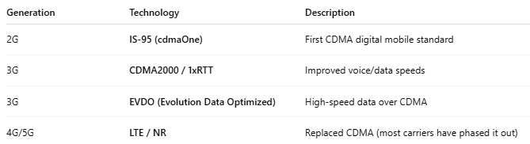

Generation | Technology | Description
2G | IS-95 (cdmaOne) | First CDMA digital mobile standard
3G | CDMA2000 / 1xRTT | Improved voice/data speeds
3G | EVDO (Evolution Data Optimized) | High-speed data over CDMA
4G/5G | LTE / NR | Replaced CDMA (most carriers have phased it out)

🌍 Where CDMA Was Popular:
# Source: Chatgpt (GPT-5-Mini) at [1/23/2026]
- 🇺🇸 United States (Verizon, Sprint)
- 🇨🇳 China (China Telecom)
- 🇰🇷 South Korea (early SK Telecom)
- 🌎 Some parts of India, Japan, and Canada

📤 How CDMA Works (Simplified):
# Source: Chatgpt (GPT-5-Mini) at [1/23/2026]
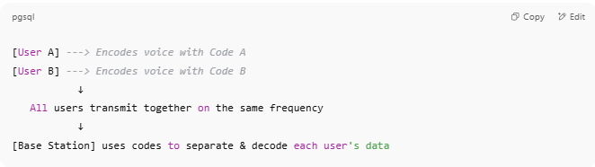

[User A] ---> Encodes voice with Code A
[User B] ---> Encodes voice with Code B
↓
All users transmit together on the same frequency
↓
[Base Station] uses codes to separate & decode each user's data

⚠️ CDMA Today:
# Source: Chatgpt (GPT-5-Mini) at [1/23/2026]
- 📴 CDMA is obsolete or being phased out in most regions
- 📲 Modern networks use GSM-based LTE and 5G
- 🔁 Many CDMA networks have already shut down (e.g., Sprint CDMA retired in 2022)

📖 Summary:
# Source: Chatgpt (GPT-5-Mini) at [1/23/2026]
CDMA is:
- A radio access method used in 2G/3G mobile networks
- Uses code separation instead of time/frequency division
- Provided strong voice/data services, especially in the U.S.
- ✅ Efficient and secure — but largely replaced by 4G LTE and 5G

